SWAG

Order Form
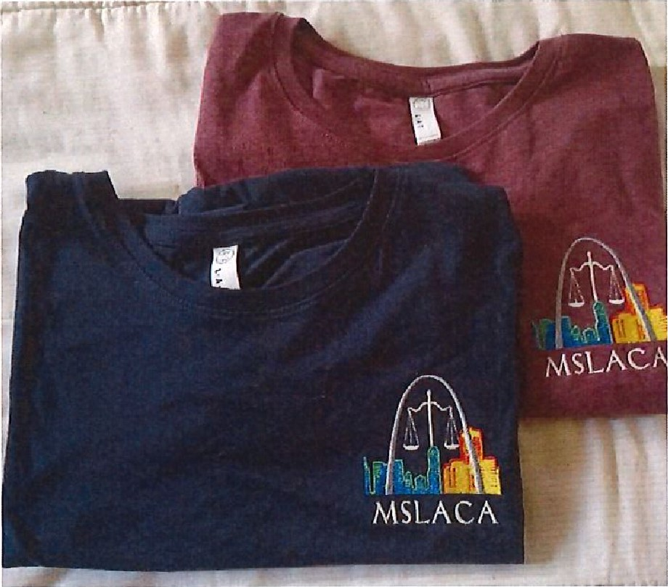
Name: ______________________________
Court: _______________________________
Size: ________________________________
Please circle:
Tee Shirt (Navy Blue or Red) OR Jacket

Circle: Cash or Check if check please give check #
MAKE CHECKS PAYABLE TO AND MAIL TO: M.S.L.A.C.A.
P.O. Box 32903
St. Louis, Mo 63132

