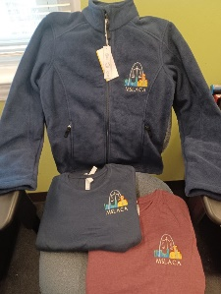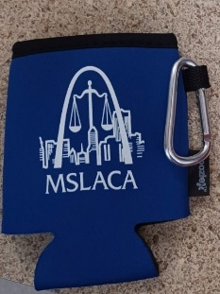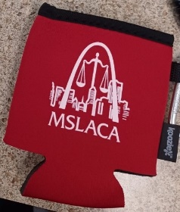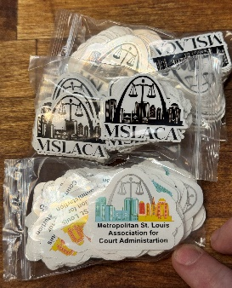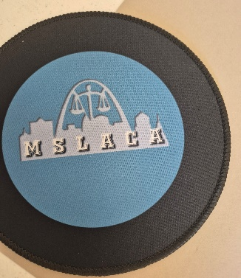

Name: ______________________________
Court: _______________________________
Size: ________________________________
Please circle correct item below:
Tee Shirt $15.00 (Navy Blue or Red)
BLUE: M L XL 2X 3X
RED: M L XL 3X

Fleece Jacket $40.00
Koozies $5.00 (Red of Blue)
Mouse Pad $5.00
MSLACA Stickers $2.00(for 1) or $5.00(for 3)

Circle: Cash, or Check if check please give
Check # Amount Received $_________

MAKE CHECKS PAYABLE TO AND MAIL TO: M.S.L.A.C.A.
P.O. Box 32903 St. Louis, Mo 63132

